EPANET and WNTR Unit Discrepancy

Main Questions:
These questions will make more sense once you’ve read everything below, but I wanted to put them up front so they are obvious.
- What units are the WNTR simulation results in, specifically for demand?
- What unit conversions does WNTR use in the backend that could potentially change the output demand?

Description of Problem:
The discrepancy that I have found is that the output demand units of EPANET and WNTR don’t align, and I can’t find a conversion that would satisfy the difference. I arrived at this conclusion because I have been running my ABM on the Clinton network and the water age I get in EPANET is many times larger than what I get in WNTR. When I started to explore the reasoning, I looked at the demand at specific nodes and found that the demand reported by WNTR is much larger than what is reported in EPANET. I have run simulations with both Clinton and Micropolis, and I get somewhat different results from both. I will try to outline what I have found.

Methods?:
To create a fair test, I run my COVID-19 social distancing and tap water avoidance ABM (COST-ABM, what do you think of the name) using the Stepwise WNTR solver that David Hart posted, that uses the EpanetSimulator (you have access to my code on GitHub, the Micropolis work is in branch gini, and the Clinton work is in branch Clinton). Once I am done running the ABM, I save the WaterNetworkModel object (model.wn) to an input file using the following call:

write_inpfile(
model.wn,
‘final_wn_' + str(id) + '.inp',
units=model.wn.options.hydraulic.inpfile_units
)

I then open this INP file in EPANET and run it for the same duration as the ABM and compare the demand and water age for individual nodes.

Micropolis:
When I run the test described above with the Micropolis network I get similar water age results (Figure 1) and similar demand trends, but very different demand values (Figure 2). This is good news for me, because my current paper relies on the water age and it seems like the water age matches what EPANET is getting. As for the demand, I can’t figure out what units the WNTR results are reporting. To generate these plots, I take the results output from WNTR and plot one column, i.e., one node. I don’t perform any manipulation to the data.
From the WNTR documentation, the simulation results for demand should be stored as m³/s. If that is the case, then we should be able to convert to gpm like this:
$$40\frac{m^{3}}{s}*264\frac{gal}{m^{3}}*60\frac{s}{min}=633,600\frac{gal}{min}$$
This is almost similar if you assume the results from WNTR are micro m³/s or:
$$40 x {10}^{-6}\frac{m^{3}}{s}*264\frac{gal}{m^{3}}*60\frac{s}{min}=0.63\frac{gal}{min}$$
As this is close to the maximum value of 0.6 in the figure from EPANET (Figure 2).
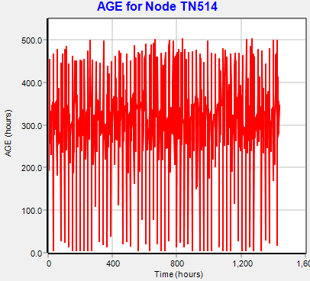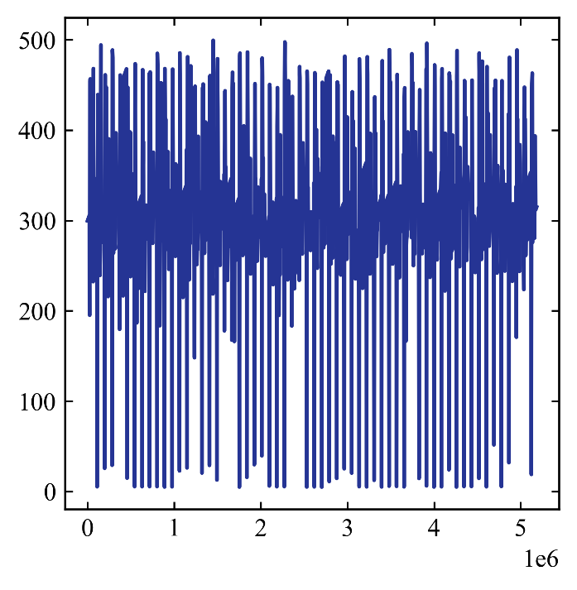
Figure 1: Water age for the 60-day simulation of Micropolis from EPANET (left) and WNTR results (right). X-axis is the same scale, don’t worry about it…
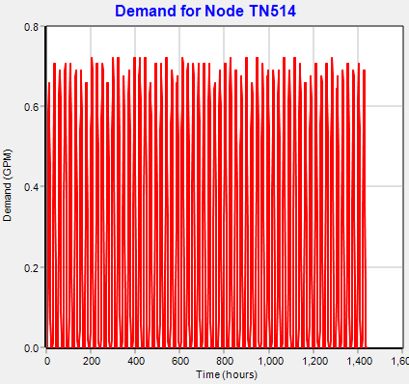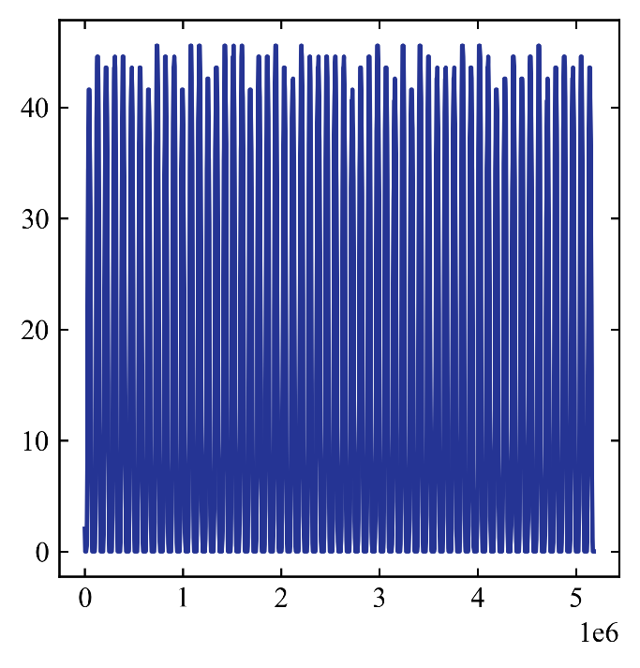
Figure 2: Demand for the 60-day simulation of Micropolis from EPANET (left) and WNTR results (right). X-axis is the same scale, don’t worry about it…

Clinton:
Here’s where things get more interesting. I have applied the ABM to the Clinton network that Elias generated using PipeNetGen and now I have discrepancies in both the water age and the demand (Figures 3 and 4). Both water age and demand show similar trends in EPANET and WNTR, but now the magnitude of both is different between the two solvers. The water age is lower from WNTR and if we do the same conversion from Micropolis it seems like the demand is higher in WNTR (which would explain the decrease in water age – higher demand, lower water age).
$$30 x {10}^{-6}\frac{m^{3}}{s}*1000\frac{l}{m^{3}}=0.03\frac{l}{s}$$
Where 30 looks to be about the average demand from WNTR, it corresponds to a value higher than the average from EPANET (0.02 lps). The other major difference you see with Clinton is that it is using LPS as the flow unit in EPANET, whereas Micropolis uses GPM. I can’t really see how that would change things assuming the base demands are defined correctly, which I have verified, and I am running the same base demands in EPANET and WNTR based on the INP file I generate at the end of the ABM simulation. That is to say, even if I have incorrectly defined the base demands in the ABM, they would be the same base demands in the EPANET simulation.
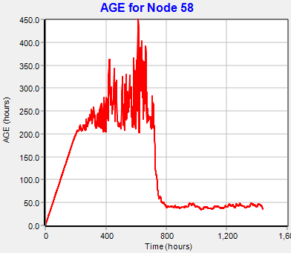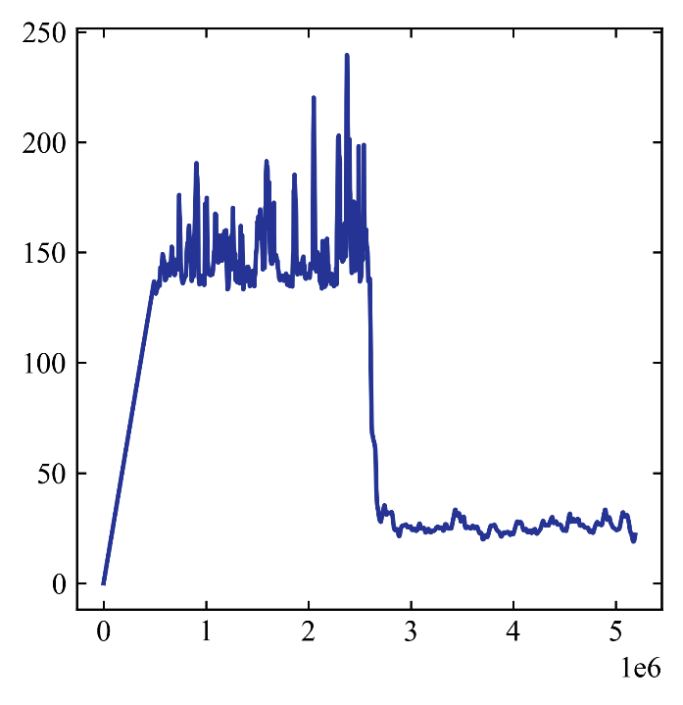
Figure 3: Water age for the 60-day simulation of Clinton from EPANET (left) and WNTR results (right). X-axis is the same scale, don’t worry about it…
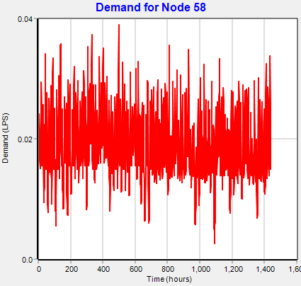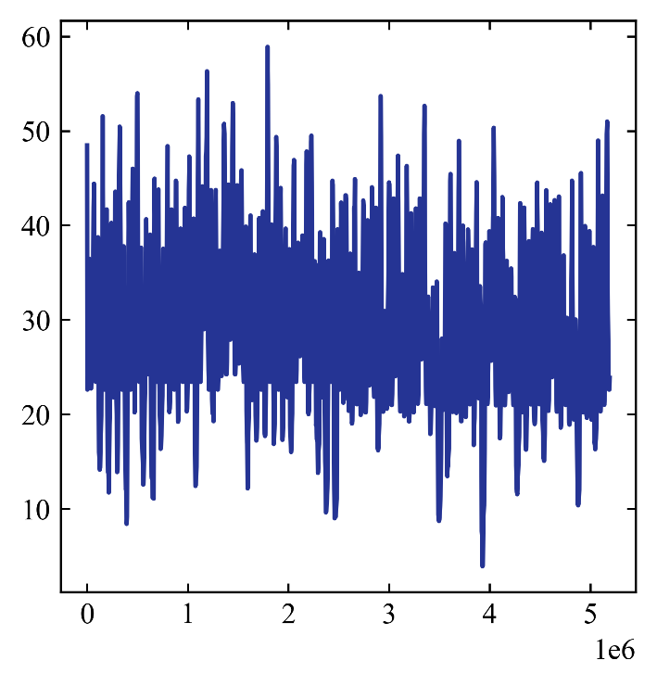
Figure 4: Demand for the 60-day simulation of Clinton from EPANET (left) and WNTR results (right). X-axis is the same scale, don’t worry about it…

